**Project 3: Create a chatbot in Python**

**Phase 2: Innovation**

**Introduction:**

Using pre-trained language models like GPT-3 to enhance the quality of responses is indeed an advanced and effective technique. These models are trained on large amounts of text data and can generate human-like text, making them valuable for various applications.

**Ways to improve quality of GPT-3:**

Here are some ways you can leverage pre-trained language models to enhance response quality:

1. Text Generation:

- GPT-3 can generate coherent and contextually relevant text. You can use it to automatically generate responses for chatbots, virtual assistants, or content generation.

2. Sentiment Analysis:

- You can use GPT-3 to analyze the sentiment of text input. This can be helpful for assessing customer feedback, social media sentiment analysis, or monitoring brand reputation.

3. Content Summarization:

- Pre-trained models can be employed to summarize long articles or documents efficiently. This can save time for users and help them quickly grasp the main points of a text.

4. Language Translation:

- GPT-3 can be used for language translation tasks. It can translate text from one language to another, making it valuable for international communication and content localization.

5. Question Answering:

- Pre-trained models can answer questions based on the context provided. You can use them to build intelligent question-answering systems or assist users in finding information.

6. Personalization:

- You can personalize responses by fine-tuning a pre-trained model with user-specific data. This can result in more tailored and relevant interactions.

7. Conversational Agents:

- GPT-3 can be integrated into chatbots or virtual assistants to engage in natural and dynamic conversations with users. It can handle multi-turn conversations and maintain context effectively.

8. Content Recommendations:

- Analyze user preferences and behavior to recommend content or products. Pre-trained models can help in understanding user intent and suggesting relevant items.

9. Automatic Tagging and Categorization:

- Use pre-trained models to automatically tag and categorize text content, making it easier to organize and search for information.

10. Text Summarization for Search:

- Enhance the quality of search results by generating concise summaries of search results. This can help users quickly assess which links to click on.

11. Creative Writing and Content Generation:

- Generate creative content, such as stories, poems, or marketing copy, using pre-trained models. They can assist in brainstorming ideas and crafting engaging narratives.

12. Text Completion and Suggestions:

- Offer text completion suggestions as users type, making their writing more efficient and error-free.

**Defenition:**

GPT-3, which stands for "Generative Pre-trained Transformer 3," is a state-of-the-art language model developed by OpenAI. It represents the third iteration of the GPT series, following GPT-1 and GPT-2. Here are some key points about GPT-3:

1. Architecture: GPT-3 is built upon the Transformer architecture, which has become the dominant model architecture for natural language processing tasks. It employs a deep neural network with attention mechanisms.

2. Pre-training: GPT-3 is pre-trained on a massive amount of text data from the internet. It learns to predict the next word in a sentence, which helps it understand and generate human-like text.

3. Scale: One of the distinguishing features of GPT-3 is its enormous size. It consists of 175 billion parameters, making it one of the largest language models ever created at the time of its release.

4. Generative Capability: GPT-3 can generate coherent and contextually relevant text when given a prompt. It can be used for tasks such as text generation, language translation, text summarization, and question answering.

5. Zero-shot and Few-shot Learning: GPT-3 has the ability to perform zero-shot and few-shot learning, meaning it can perform tasks it wasn't explicitly trained for by providing it with a prompt or a few examples of the task.

6. Fine-tuning: Users can fine-tune GPT-3 on specific tasks or domains to improve its performance on particular applications.

7. Applications: GPT-3 has been used in a wide range of applications, including chatbots, content generation, language translation, code generation, and more. It has also sparked interest in ethical and safety considerations in AI due to its ability to generate realistic but potentially biased or harmful content.

8. API Access: OpenAI provides access to GPT-3 through an API (Application Programming Interface), allowing developers and organizations to integrate GPT-3 into their applications and services.

9. Cost: Using GPT-3 via the API comes with associated costs, which depend on usage and volume.

**Code:**

import tensorflow as tf

import numpy as np

import pandas as pd

import matplotlib.pyplot as plt

import seaborn as sns

from tensorflow.keras.layers import TextVectorization

import re,string

from tensorflow.keras.layers import LSTM,Dense,Embedding,Dropout,LayerNormalization

df=pd.read_csv('/kaggle/input/simple-dialogs-for-chatbot/dialogs.txt',sep='\t',names=['question','answer'])

print(f'Dataframe size: {len(df)}')

df.head()

**Output:**

Dataframe size: 3725

|  |  |  |
| --- | --- | --- |
| **S.No** | **Question** | **Answer** |
| 0 | hi, how are you doing? | i'm fine. how about yourself? |
| 1 | i'm fine. how about yourself? | i'm pretty good. thanks for asking. |
| 2 | i'm pretty good. thanks for asking. | no problem. so how have you been? |
| 3 | no problem. so how have you been? | i've been great. what about you? |
| 4 | i've been great. what about you? | i've been good. i'm in school right now. |

**Visualization of data:**

df['question tokens']=df['question'].apply(lambda x:len(x.split()))

df['answer tokens']=df['answer'].apply(lambda x:len(x.split()))

plt.style.use('fivethirtyeight')

fig,ax=plt.subplots(nrows=1,ncols=2,figsize=(20,5))

sns.set_palette('Set2')

sns.histplot(x=df['question tokens'],data=df,kde=True,ax=ax[0])

sns.histplot(x=df['answer tokens'],data=df,kde=True,ax=ax[1])

sns.jointplot(x='question tokens',y='answer tokens',data=df,kind='kde',fill=True,cmap='YlGnBu')

plt.show()

**Output:**

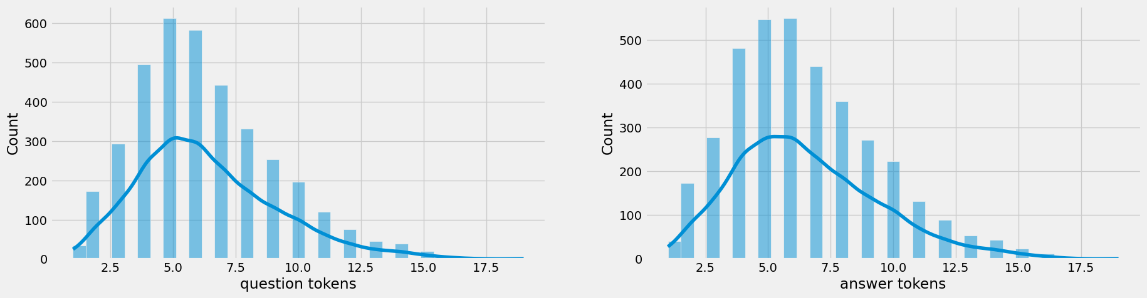

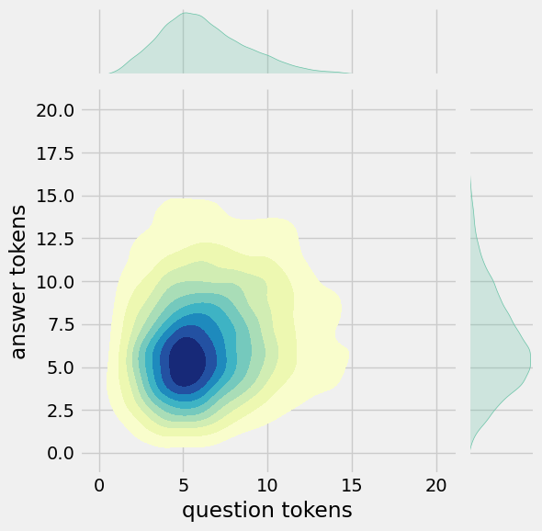

**Project By:**

**NAME:** M. Deepak

**DEPT:** CSE III YEAR

**COLLEGE:** AKT MEMORIAL COLLEGE OF ENGINEERING

**GROUP:** AI GROUP-5

**REG NO:** 420121104017